

**TRINITY HIGHLIGHTS**

**DECEMBER 2017**

**A monthly newsletter of Trinity Lutheran Church**

**Greencastle, PA**

"Sharing Christ in Word and Deed"

SUNDAY WORSHIP 8:30 & 11 AM

SUNDAY SCHOOL 10:00 AM

1186 Jason Drive Email: tlcgreencastle@embarqmail.com

Greencastle, PA 17225 Secretary: tlcsec@embarqmail.com

717-597-9348 Website: [www.tlcgreencastle.org](http://www.tlcgreencastle.org/)



**PASTOR'S LETTER**

Dear sisters and brothers in Christ,

All of life is preparation for what is yet to come. Sometimes we may wonder for what we are being prepared, especially when we go through troubling times. Yet, when various situations arise to assist someone else, we are able to speak from experience on how God helped us.

Advent is a season of preparation. Most folks are preparing for Christmas. That means decorations, shopping, baking and the like. These are just touching the surface of the real event for which we are getting ready. We are, indeed, getting ready to celebrate the birth of the Christ Child. But, he has already come.

Christ promised he would come again. How can we ever get ready for that? We want to know the where and when of this event. But, Jesus said that no one but the Father knows the timing.

Advent begins with a call to watchfulness. The gospel writers admonish us to keep awake. The second Sunday urges us to prepare the way of the Lord. Make it easy for him to reach you and the rest of the world.

Advent is a call to prayer, not a call to busyness. It invites us to take time for silence. Take time to look at the world and see where help is needed and find how we can make a difference in the name of Jesus.

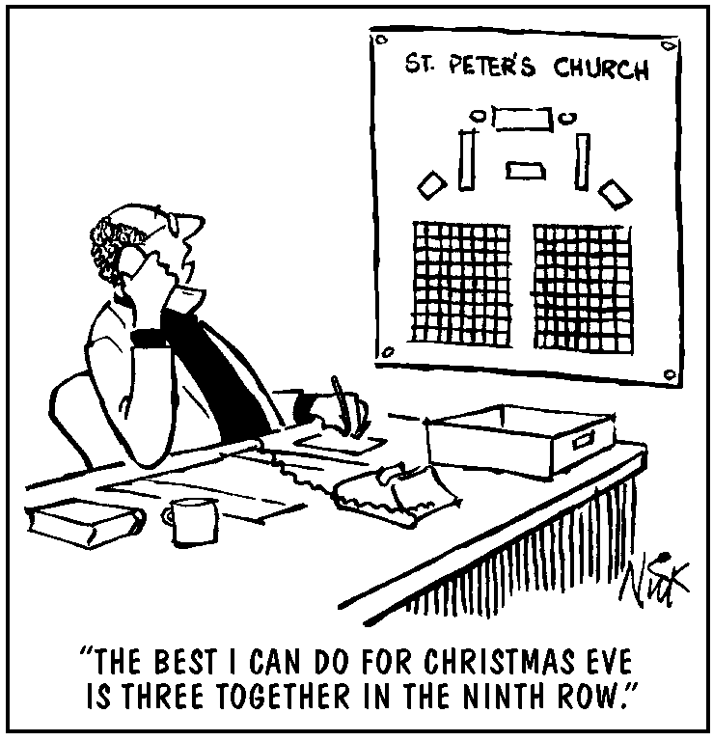We tend to want to rush right into Christmas. We enjoy the celebrations, the lights, the music and the joy. However, it is worthwhile to examine our lives and consider why we need Christmas at all. Do we take time to prepare the way of the Lord? Do we use Advent devotions? The table in the lobby has papers which can be folded into a star. These contain prayers from students and staff of United Lutheran Seminary. Consider having your own Advent wreath at home. Take time to slow down and pray for this world of ours

A popular phrase says “Jesus is the reason for the season.” Yes, his birth is reason for celebration. But the real reason for the season lies in what made it necessary for God to send the Christ child. The real reason is our sinful lot. We need Jesus for our forgiveness. Without that, there would be no hope.

Understanding our need for a savior makes the holiday all the more precious and powerful good news. As one of my favorite carols proclaims, “Good Christian friends rejoice with heart and soul and voice; now ye need not fear the grave; Jesus Christ was born to save.

One way to make a difference this year is to gift people with something new. We all know people who seem to have everything. Why not buy an animal for a family in need through ELCA world hunger. Check out the Advent/Christmas tree in the lobby. The decorations show different animals or projects toward which you may contribute. Choose the one you wish to sponsor. Place the amount in an envelope marked hunger and give the decoration as your gift. If you would like more information, pick up one of the ELCA Good Gifts catalogs.

Plan to join us for worship on each of the Sundays of Advent. The children’s program will be presented on December 17 so there will be only one service that day. Christmas Eve falls on Sunday this year. The morning worship will observe the 4th Sunday of Advent at the usual times with Sunday School in between. Christmas Eve worship is at 5:00 for the Family Service and 7:30 pm for the Traditional Service. On December 31 we will have a single service of lessons and carols at 10:00 AM. There will be no Sunday School that day.

May you have a blessed advent and a most joyful Christmas.

In Christian Love,

Pastor Brenda

**December 2017 at Trinity**

**Friday, December 1**

AA Meeting - 8:00 p.m.

**Saturday, December 2**

Making Apple Dumplings at ELC - 9:00 a.m.

Ornament Exchange Bingo - 6:00 p.m.

**Sunday, December 3**

Worship with Holy Communion - 8:30 a.m.

Fellowship Time following first service

Sunday School for all ages - 10:00 a.m.

Advent Craft - 10:45 a.m.-12:00 p.m.

Worship with Holy Communion - 11:00 a.m.

Pot Luck Lunch and Decorating - 12:00 p.m.

**Monday, December 4**

AA Meeting - 8:00 p.m.

**Tuesday, December 5**

Outreach Committee - 7:00 p.m.

**Thursday, December 7**

Choir Practice - 7:00 p.m.

**Friday, December 8**

AA meeting - 8:00 p.m.

**Sunday, December 10**

Worship Service of the Word - 8:30 a.m.

Fellowship Time following first service

Blood Pressures taken in Quiet Room

Sunday School for all ages - 10:00 a.m.

Worship with Holy Communion - 11:00 a.m.

ET/TELL Youth and Families caroling at

Luther Ridge - 2:15 p.m.

**Monday, December 11**

AA Meeting - 8:00 p.m.

**Wednesday, December 13**

Congregational Council Meeting - 7:00 p.m.

**Thursday, December 14**

Choir Practice - 7:00 p.m.

**Friday, December 15**

AA Meeting - 8:00 p.m.

**Sunday, December 17**

ONE WORSHIP SERVICE WITH CHILDREN'S CHRISTMAS PROGRAM AT 10:00 a.m.

Congregational Meeting following the Service

**Monday, December 18**

Stewardship Committee - 7:00 p.m.

AA Meeting - 8:00 p.m.

**Wednesday, December 20**

Worship and Music Committee - 7:00 p.m.

**Thursday, December 21**

Choir Practice - 7:00 p.m.

**Friday, December 22**

AA Meeting - 8:00 p.m.

**Sunday, December 24**

Worship Service of the Word - 8:30 a.m.

Fellowship Time following first service

Blood Pressures taken in Quiet Room

Sunday School for all ages - 10:00 a.m.

Worship with Holy Communion - 11:00 a.m.

**Christmas Eve**

Informal Candlelight Communion Service for Families and Others - 5:00 p.m.

Traditional Candlelight Communion Service 7:30 p.m.

**Monday, December 25**

AA Meeting - 8:00 p.m.

**Tuesday, December 26**

Finance Committee - 7:00 p.m.

**Friday, December 29**

AA Meeting - 8:00 p.m.

**Sunday, December 31**

A Service of Lessons and Carols - 10:00 a.m.



**PLEASE REMEMBER THESE PEOPLE**

There are some folks from Trinity who are not able to be with us on Sundays at the present time. We ask that you would remember them with a card - and always - in prayer.

**Jean Jimick**

Providence Place

2085 Wayne Avenue

Chambersburg, PA 17202

**Karen & Jake Johns**

204 S. Washington Street, Apt. 1

Greencastle, PA 17225

**Evelyn Pensinger**

The Inn at Luther Ridge - Room 10

2735 Luther Drive

Chambersburg, PA 17202

**Worship Assistants**

**December 2017**

**Assisting Ministers:**

3 - Dave Wolfe

10 - Cameron Schroy

17 - Carol Swart

24 - Don Swart

31 - Dave Wolfe

**Lay Readers:**

3 - Sue Snyder

10 - Carol Swart

17 - Don Swart

24 - James Thomas

31 -

**Ushers:**

3 - Gust Barbuzanes, Ralph Burdick, Don Swart

10 - Charlie Ford

17 - Bruce DeMaster, Charlie Ford, Richard Miller

24 - Darrell Swart, Bud Wolfe, Dave Wolfe

31 - Gust Barbuzanes, Ralph Burdick, Ed Osbaugh

**Acolytes:**

3 - Grace Cessna

10 - Madison Cessna

17 - Connor Cline

24 - Kristen Louder

31 -

**Greeters:**

3 - Alice Marsh

10 - Charles and Nancy Freshman

17 - Erin, Dorian and Lydia Pryke

24 - Ed and Nancy Osbaugh

31 - Don and Carol Swart

**Nursery**

3 - Linde Cessna

10 - Debbie Cline

17 - Michelle Kline

24 - Mary Thomas

31 - Sarah Wolfe

**Cantors**

3- Matt Cessna

10 - Trevor Timmons

17 -

24 - Dave Wolfe

31 - Ralph Burdick

**Communion Presenters:**

3 - James, Mary and Larson Thomas

17 - Darrell and Jess Swart

31 -

**Communion Assistants: - 8:30 a.m. Service**

3 - Donna Wolfe and Sue Wumderlich

17 - Dave Cline and Nancy Freshman

31 -

**Communion Preparers**

3 - Keith and Pam Arnold

17 - Bud and Donna Wolfe

31 -

**Blood Pressures Taken by:**

10 - Charlie Ford

24 - Stacie Wolfe

**Ushers - 11:00 a.m. Service**

3- Dot Potter

10 - Dave Brown

17 - ONE SERVICE AT 10:00 AM

24 - Peggy Potter

31 - ONE SERVICE AT 10:00 AM

**Communion Assistants - 11 a.m. Service**

3- Dave Wolfe and Peggy Potter

10 -Cameron Schroy and Donna Wolfe

17 -ONE SERVICE AT 10:00 AM

24 -Don Swart and Peggy Potter

31 -ONE SERVICE AT 10:00 AM



2 - Robert Witmer

5 - Renee Swart

Nancy Osbaugh

Sue Wunderlich

6 - Carolyn Clark

7 - Ginger Shriver

13 - Chuck Wunderlich

14 - Ray Reihart

16 - Rick Landry

18 - Carol Swart

19 - Gust Barbuzanes

20 - Doris Burdick

Sarah Wolfe

22 - Jack Phillippy

23 - Sojourner Stevenson

27 - Mary Thomas

31 - Joan Hall

12 - One Service at 10:00 a.m.

19 - Roger Johns

26 - Peggy Potter



31 - Charlie and Beth Ford

***DATES TO REMEMBER***

**DECEMBER 17**

ONE SERVICE AT 10:00 AM with

Children's Christmas Program

Congregational Meeting Following Worship

**DECEMBER 24**

Service of the Word 8:30 AM

Service of Holy Communion 11:00 AM

Informal Candlelight Communion - 5:00 PM

Traditional Candlelight Service - 7:30 PM

**December 31**

ONE SERVICE AT 10:00 AM

A Service of Lessons and Carols

**Annual Meeting**

The annual Congregational Meeting will be held after the worship service on December 17. We will be looking at the 2018 budget and electing Congregational Council members. All voting members should plan to attend. Members who are willing to be nominated to serve on Council are still needed. Please speak with Beth Ford if you are interested. She can be reached at 717-446-1102.



**Can You Help?**

* Worship Assistants are needed forboth the 5:00 PM and the 7:30 PM services on Christmas Eve. If you can serve, please sign the sheet on the bulletin board in the Lobby or if you have any questions, please see Donna Wolfe.
* We are also in need of people who would be willing to read for the *Service of Lessons and Carols* which will be held at 10:00 a.m. on December 31. If you would be willing to read one of the lessons, please see Pastor Brenda.
* A Pastor living in Greencastle is in need of volunteers to take her to therapy at Peak Performance on S. Washington Street two times a week. If you would be able to help her, please call Pastor Ruth Smith at 717-496-0789.

**NEWS FROM OUR YOUTH**



**Children's Christmas Program**

There will be only one service on Sunday, December 17 so that everyone can enjoy the Children's Christmas Program. Bring your appetite as the chefs of "Icing for the King" bakery whip up orders to find the true meaning of Christmas!

**Christmas Caroling at Luther Ridge**

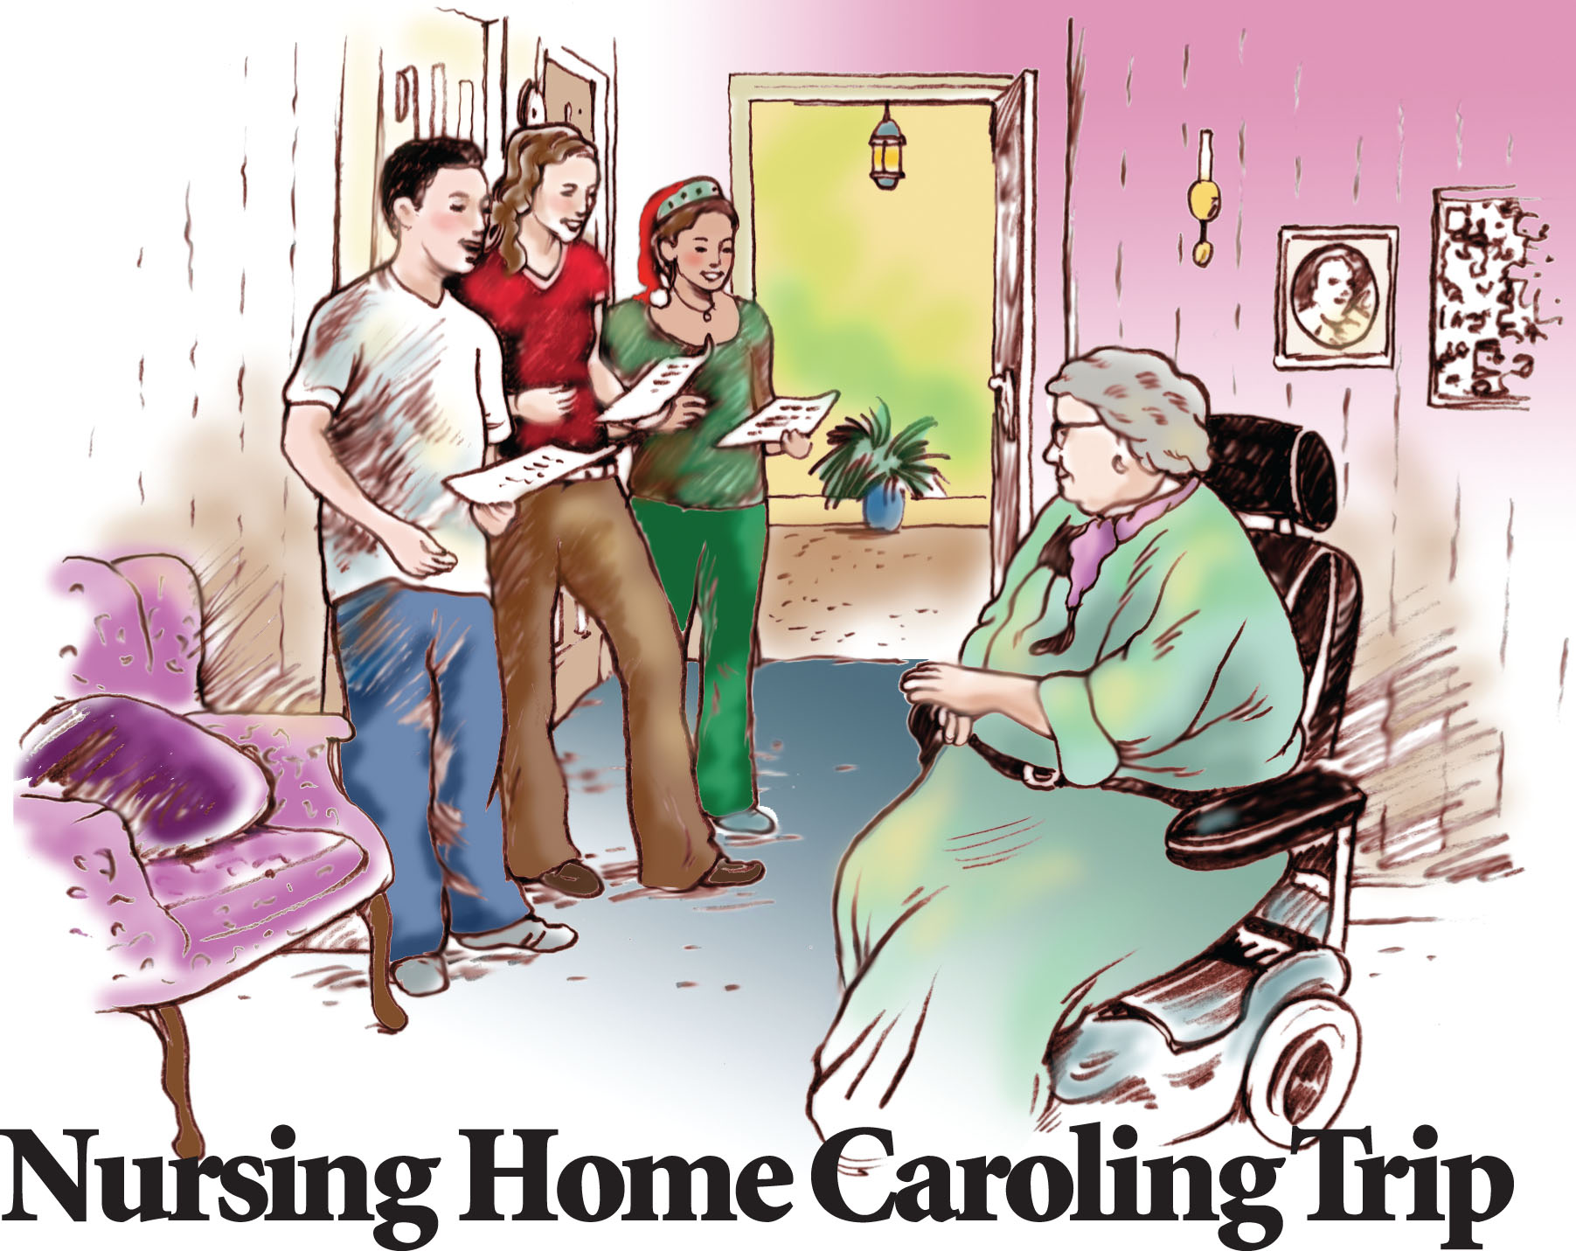TELL and ET Families are invited to meet in the parking lot at Luther Ridge between 2:15-2:30 p.m. on December 10.  We will be caroling through the hallways and passing out the Christmas craft/cards made at the Nov 19 meeting.   Please let us know if you and your family will be attending.

**ET Youth Group Fundraiser**

The ET Youth Group is excited about their fundraiser. They will be selling gift cards from December 2nd – December 10th with over 250 national vendors to choose from. Local vendors include Giant Foods, Sheetz, Olive Garden, Texas Roadhouse, Bed, Bath & Beyond, Kohl’s, Home Depot, Lowe’s, and Walmart, just to name a few. A complete list of vendors can be found at <https://www.scripzone.com/certificatelist.aspx>. If you plan to purchase gift cards for Christmas or if you make regular purchases at any of the vendors listed, please consider purchasing cards through this program. Gift cards are sold for their face value, but ET Youth Group will make between 1.5%-18% profit on each card. Orders can be placed December 3rd and 10th after the 8:30 service and before the 11:00 service, or by contacting Peggy Louder at 717-328-5338. They will be available to pick up on December 17th. Checks should be made payable to *ET Youth*.

Due to the success of our 2017 Book Sale we were able to give $2,000.00 to Habitat for Humanity of Franklin County. We also were able to give $400.00 each to The Lunch Place, Fulton County Food Basket and Women In Need. Trinity is also being given $400.00. This money will be divided between Current Expenses and the Building Fund.

Thanks to the 43 members of Trinity who volunteered and helped make the sale a success!

**December Special Appeal**

The Special Appeal for Decemberis Women In Need (WIN). Over the past 40 years WIN has made it possible for countless victims and their children to take steps to move beyond the violence in their lives and to not only survive but thrive.

A 29 year old domestic violence victim writes: *"I cannot even begin to tell you how much Women In Need services helped me and my two children this last year. We were in a very rough situation and my ex tried to kill me in front of them, and I decided that I had had enough abuse. I was fearful in leaving but I turned to WIN and I would not be here today if it were not for them.*

Services are provided to both Franklin and Fulton County, Pennsylvania. If you desire to make a donation, please mark your envelope for "Special Appeal" or use the white envelope in the pew rack and mark it "Special Appeal".

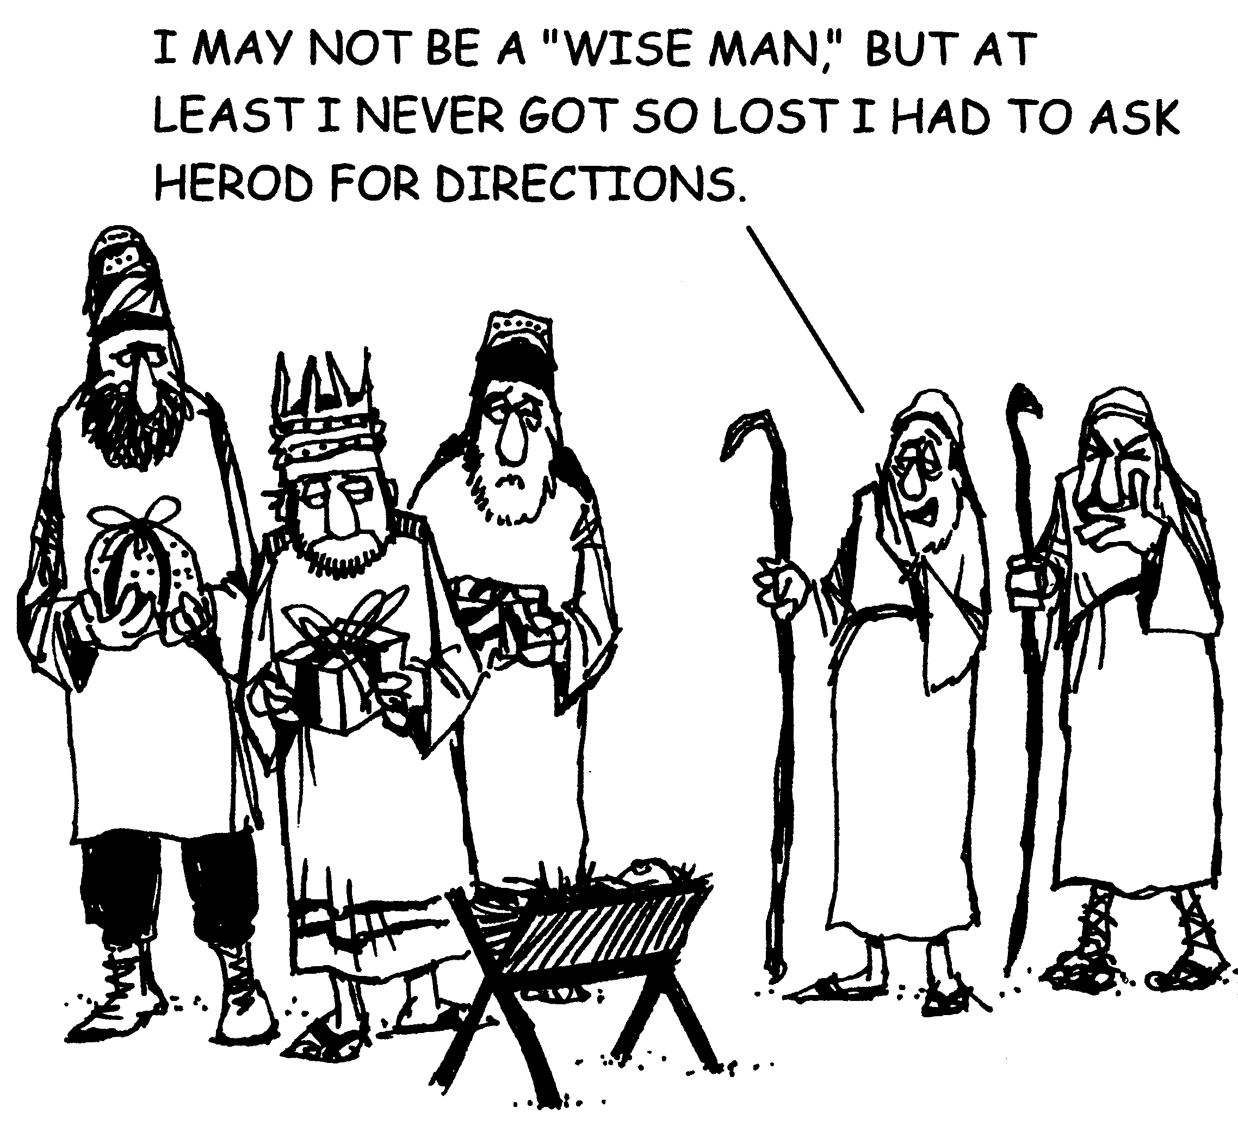

**Director of Children, Youth and Family Ministry Needed**

First Evangelical Lutheran Church in

Chambersburg, PA is seeking a part-time Director of Children, Youth & Family Ministry with primary responsibilities to further develop ministry with younger persons in our congregation and community.  The candidate will have a solid Christian faith with appropriate educational background; strong relational abilities with both young people and adults; the skill to work within a team and be a team leader; and the flexibility of scheduling to be available to work days, nights, and weekends.  The position is for 25 hours per week on a salary basis of $25,000 - $30,000 per year.

For a full job description contact [flcpastor@outlook.com](mailto:flcpastor@outlook.com) or visit  [www.felcc.org](http://www.felcc.org)  (front page).   Resumes will need to be submitted by December 15, 2017

[](https://community.elca.org/good-gifts-2017/animals?&nccsm=21&__nccspID=126)**ELCA Good Gifts**

Pastor Brenda in her December Pastor's Letter lifts up the ELCA Good Gifts appeal. An Advent/Christmas tree has been set up in the Lobby. The decorations show different animals or projects toward which you may contribute. These gifts can be given in honor of a friend or loved one. There are many to choose from but here are three examples:

* Purchase 10 chicks for $10. These chicks make a big difference to families in many parts of the world. Eggs supply protein-rich meals and also help bring in steady income.
* Our friendly goat above is $50. Goats survive in places where other animals can't. They also provide fresh milk for the children and their offspring can be shared with other families.
* $20 will provide communion supplies for an ELCA missionary.

Choose the gift you wish to sponsor and place the amount in an envelope marked "HUNGER". Give the decoration as your gift. More information is available in the Good Gifts catalogs in the Lobby.